Project Status Report

数字校园

V 1.0

Erin Wang
Project Manager



Sep 7, 2001

Document Control

Change Record

Date | Author | Version | Change Reference
9/7/2001 | Erin Wang | V1.0

Reviewers

Date | Name | Position
9/7/2001 | John, Erin

Approved By

Name | Position | Signature | Date
The copy numbers referenced above should be written into the Copy Number space on the cover of each distributed copy. If the document is not controlled, you can delete this table and the Copy Number label from the cover page.

CONTENTS

1. Customer Complains 4
2. Milestones/Tasks Achieved 4
3. Milestones/Tasks Planned for next period 4
4. Quality Assurance Activities 4
5. Issues 4
6. Number of Requirement Change Request 4
7. Major Changes from the Plan 5

Customer Complains
No teacher monitor showing system.

Milestones/Tasks Achieved
Milestones/Tasks | Status | Remark | Deliverables | Delay
Software High Level Design | Complete |  | User Interface Design  Database Design  Functional Architect Design | 1days

Milestones/Tasks Planned for next period
Time: Sep 10-Sep 27
Milestone: Detail Design
Deliverables:
- Detail Design Document

Quality Assurance Activities
QA Activity | Defects detected | Defects closed | Defects open
User Interface Design | 13 | 13 | 0
Database Design | 10 | 10 | 0
Functional Architect Design | 5 | 5 | 0

Issues
No. | Issue | Raised by | Action by | Status
1 | Need to JSP design document | Erin | Eric | Close
2 | ER-studio can show the Chinese | Robin | Robin | Close
3 | Finish some part of JSP before 9.14 | Erin | Eric | Open
4 | Need Detail Design Plan Meeting | Erin | Erin | Open

Number of Requirement Change Request

Major Changes from the Plan

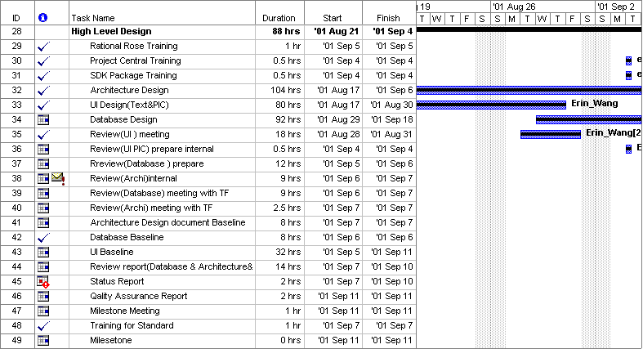
Standard Tailoring Record

Delete Item:
Item Name | Reason
Add Item:
Item Name | Reason
Modify Item:
Item Name | Reason | Modification

